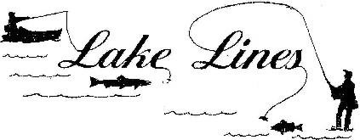
KNIFE LAKE SPORTSMEN'S CLUB--Your Lake Association
www knifelake.us
Editor: Terri Moeller (763-614-4690)
Volume 2024 October


Welcome to September, the start of the beautiful color changing sights. The KLSC had its annual volunteer dinner & it was amazing to see everyone who came to the cookout dinner & went home with some cash for helping out!!! The KLSC is ramping up for 2/1/25. MARK YOUR CALENDARS for the WDOF with the Pancake Breakfast, followed by your choice of BINGO or Ice Fishing!! Details to follow about the WDOF Big Ticket Raffle prize this year. I’d also like to welcome Amy Smyser to the KLSC Board.

Thank you to our local businesses who helped sell our Summer Raffle tickets: The Crow’s Nest Resort, Northwoods Steakhouse, Almost Yours Gun & Pawn, and Mora Marine/Northstar Pontoons! Congrats to the Summer Raffle winners: Pattie O - 4wheeler, PJ & John Sunt - $1000 & Luke Anderson - $500. Thanks to everyone who helped support this raffle with ticket purchases. Hunting season has also started. To everyone who hunts, I wish them a safe & plentiful harvest.

Ed Hamlin President KLSC pres@knifelake.us 952-250-0642

KLID Report Sept 24
Not much to report from the Sept meeting. Curly Leaf Pondweed letters will be mailed out to all residents on 1/3/25. Welcome to the KLID board Jamie Davis!! The KLID November meeting is canceled, so the board members can enjoy the deer hunting season. For info on nuisance weeds, please see https://www.dnr.state.mn.us/apm/index.html

Ed Hamlin KLSC President pres@knifelake.us


FALL CHILI FEED
Spice up your life! Join us Saturday, October 19th for our annual chili feed and cook off at 4:30pm for the cocktail hour and dinner at 5:00pm. Enjoy a hot bowl of chili and/or bring your favorite recipe in a crockpot and share with new friends and old!

2024 Deer Hunting Season Dates to remember:
09/14/24 - 12/31/24 Deer - Archery
Statewide 10/17/24 - 10/20/24 Deer - Early Antlerless
10/17/24 - 10/20/24 Deer - Youth
Statewide 11/9/24 - 11/24/24 Deer - Firearm (Season A)
100 Series permit areas 11/9/24 - 11/17/24 Deer - Firearm (Season A)
200 & 300 Series permit areas 11/23/24 - 12/1/24 Deer - Firearm (Season B)
300 Series permit areas 11/30/24 - 12/15/24 Deer - Muzzleloader Statewide

Winter Day of Fun
It’s that time of the year for us to start ramping up our game plans for the Winter Day of Fun (WDOF). You may have noticed that we are giving away a boat instead of an Ice Castle this year. We are always looking for fresh ideas and suggestions. If you would like to join us this year to help with the WDOF, please reach out to me.
This year’s WDOF raffle tickets are a $20 donation for a grand prize of a 2025 StarCraft Patriot 16SC w/40HP merc, trailer, cover, trolling motor, and a Helix 5 from Northstar Pontoon in Mora. 2nd place: $1000 cash, 3rd place: $500 cash, 4th place: $250 cash and 5th place: $100 cash. Drawing will be held February 1st, 2025 after the ice fishing contest.
Tickets are available from any of the board members, Northwoods Steakhouse, the Crows Nest C-Store, Northstar Pontoons and Almost Yours Gun and Pawn Shop.
We are always looking for donations and volunteers! Please reach out to me if you are interested in helping us out.
Rachel Hamlin
WDOF chairperson
612-558-5894

ATTENTION: SNOW BIRDS
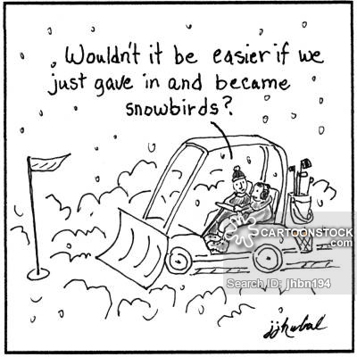
Please send your winter address and date of change to moeller95@aol.com or call Terri (763-614-4690). Lake Lines is mailed under a reduced rate permit. Even if you have a forward notice at the Post Office, copies of Lake Lines are NOT forwarded. The club is charged first class postage rates for returned copies. If your newsletter is returned for any reason, your name will be temporarily removed from the mailing list until we have your current address. We’ll need to know when you expect to leave Minnesota and the date you expect to return. THANKS!

KLSC MEMBERS…are your dues current? Check the mailing label on this issue of Lake Lines. Following your name, you will see the year for which you last paid dues. Please use the form on the outside of your newsletter. Thank you for your continuing support!
2024 dues are being received at this time!


KLSC ARCHERY

Annual Membership Sign-up Form
Archery membership can now be paid on our website, knifelake.us

Name Mailing Address City State Zip Email Phone
Membership (please circle one): NEW RENEWAL
Individual - $40 or Family - $75
Please make checks payable to Knife Lake Sportsmen’s Club (KLSC) and hand to KLSC board member, mail
to Ed Hamlin, 2675 Kite St, Mora, MN 55051, or leave in lock box on archery range. Non-member course usage is $10 per day per person.
***KLSC MUST HAVE A SIGNED “HOLD HARMLESS AGREEMENT” FOR EACH COURSE PARTICIPANT ON FILE***

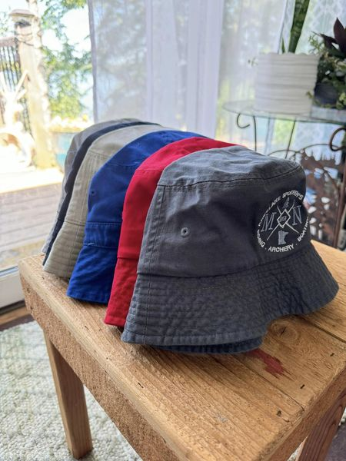
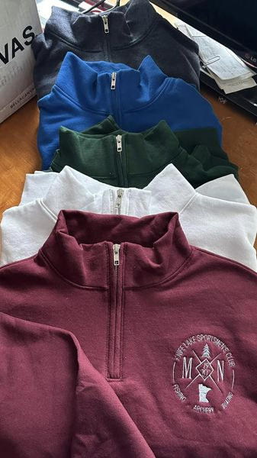

KLSC LOGO SPORTSWEAR
Check out our newest additions to the selection.
Come to a board meeting or any event at the clubhouse!


The Fall Archery Competition was a blast at the 3D course that your club provides. We awarded prizes to the best four shooters. (I didn't make the cut. LOL) We started out by shooting at a swinging target, which is always a challenge for the best Archers out there.

I want to say "Thank You" to all those that take the time to join in on our fun. It's the best way to enjoy some camaraderie and spend a Sunday afternoon. I hope you have time to join in next year!

Here's your winners with bragging rights:
1st- Levi Berg
2nd- Cole Steffawn
3rd- Mike Kastenbauer
4th- Bryce Bossen

Submitted by Wayne Whited


KNIFE LAKE SPORTSMEN’S CLUB, INC.
Annual Membership Dues for 2024 -- $35

Name(s) Lake address Phone # Mailing address if different City State Zip Phone # Email address Membership (please circle one) New Renewal Additional donation $
Make check payable to Knife Lake Sportsmen’s Club
Thank you!
and mail check with this form to:
Knife Lake Sportsmen’s Club
PO Box 254
Mora, MN 55051 Dues can now be paid on our website, knifelake.us

